Capstone Project Report

Scope:
Attacker: Kali Linux (192.168.0.133)
Targets: Metasploitable VM (192.168.0.125)

1 – Vulnerabilities Findings List
Target: Metasploitable

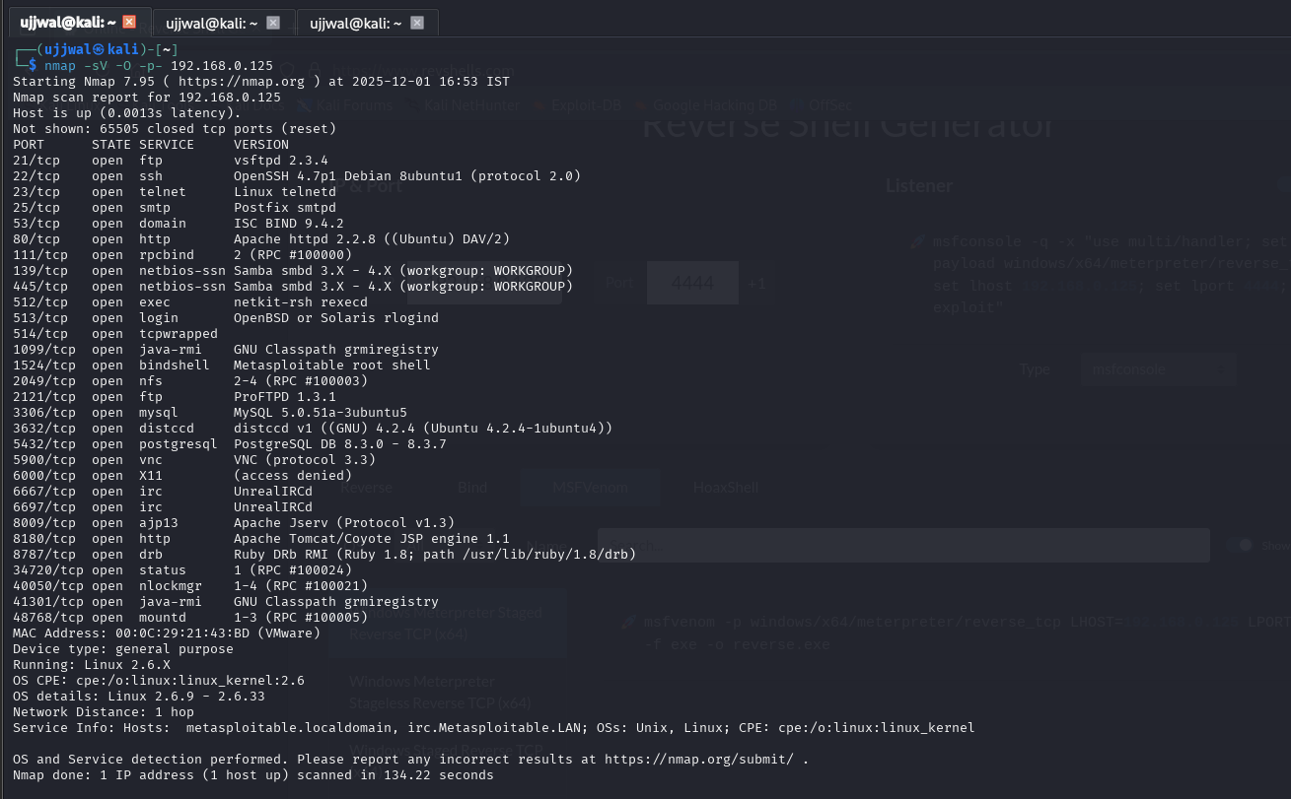

2 – Exploitation, Rescan
Target: Metasploitable Description:
Getting remote access

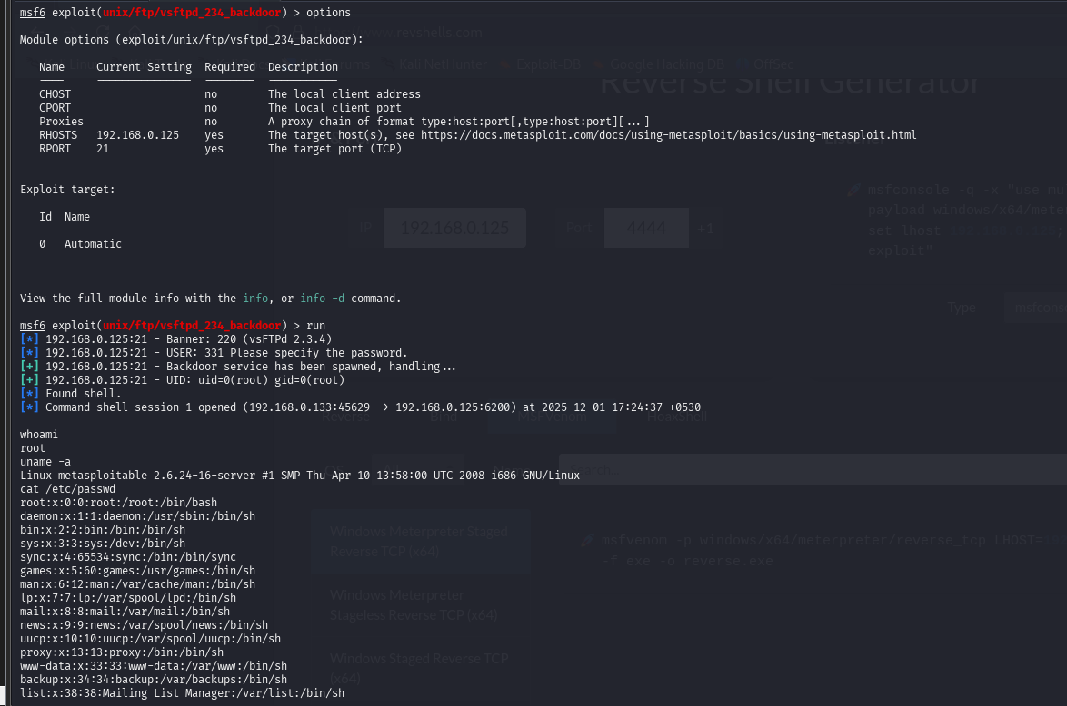
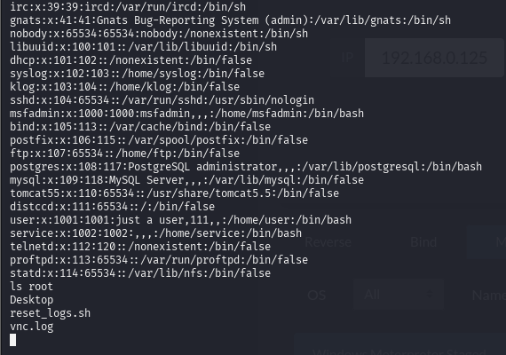

3 – Summary (Technical)

The capstone project involved performing a full PTES-aligned penetration test on the Metasploitable vulnerable VM from a Kali Linux attacker machine. Tasks included network enumeration, service fingerprinting, vulnerability scanning with OpenVAS, exploiting VSFTPD 2.3.4 using Metasploit, capturing results, validating API vulnerabilities using Burp Suite, and documenting findings with corresponding remediation and verification rescans..
4 – Summary (Non Technical)
This project simulated a real-world cybersecurity assessment to identify weaknesses in a controlled target system. Using industry-standard tools, the testing process followed professional security guidelines to detect insecure services, misconfigurations, and exploitable vulnerabilities. The assessment demonstrated how an attacker could gain unauthorized access, misuse system functions, or compromise data. After identifying these issues, clear recommendations were proposed, such as applying patches, limiting access, improving authentication, and strengthening system configurations. The project highlights the importance of proactive security testing, regular monitoring, and proper remediation to reduce risks and protect an organization’s systems from cyber threats..

